
Understanding and Managing Stress: Strategies for Wellbeing


Table of Contents
The session 2
Stress Defined 2
What is stress? 2
Good stress vs. bad stress 3
Demands that lead to stress 4
Common stress responses 4
Stress or anxiety? 5
Stress Management Strategies 5
Identify the causes of stress in your life 5
Replace unhealthy coping strategies with healthy ones 6
Practice change techniques 7
Reframe your thoughts 8
Slow-down strategies 9
Let’s reflect 10
Putting Strategy Into Practice 10
4-7-8 breathing exercise 10
“5-4-3-2-1” grounding 11
Progressive Muscle Relaxation (PMR) 12
Other actions to consider 12
Employee Assistance Program (EAP) 13
About professional support 13
Let’s reflect 14
References 15

The session
Stress has become part of our culture. The business of work and life calls on us to deliver at our highest level; to look at how we manage our time, our energy and ourselves. It can easily feel as though everywhere we turn, we hear about the stressors that people are experiencing at work and in life. Humans all have daily stressors, but that doesn’t mean stress is negative. Stress can be positive, challenging and motivating, and even inspires creativity. The key is finding our optimal level for stress and being able to manage and cope with it effectively. In this session, you will learn to identify the stressors in your life and understand the impacts.

The following key topics related to understanding and managing stress will be covered:
Define stress and learn to differentiate good stress from bad stress

Identify common sources of stress and our reactions to it

Explore stress management and coping strategies

Determine resources to help meet stress management needs
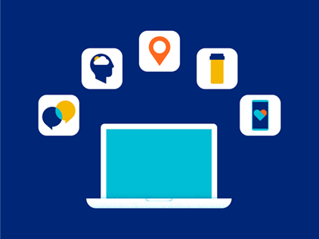

Stress Defined

What is stress?
Your work calendar is at capacity, your car won’t start, and your child’s school just called about a behavioral issue. It’s undeniable - life is full of stressful situations. With so many demands on our time, it can feel like we’re drowning in stress.
When we are stressed, our bodies release the hormones adrenaline, also known as the “fight or flight” hormone, and cortisol. They help us to respond quickly to the situation.¹

Too much stress can become chronic, and it can lead to serious health conditions that include high blood pressure, heart disease, obesity, diabetes, depression and anxiety. Sometimes, this stress response can be helpful. It can help us push through fear or pain so we can run a marathon or deliver a speech, for example. Our stress hormones usually return to normal quickly once the stressful event is over, and there won’t be any lasting effects.
A little stress is not always a bad thing. However, too much stress can cause adverse effects. It can leave us in a permanent state of fight or flight, leaving us overwhelmed or unable to cope.² Long term, too much stress can affect our physical and mental health.

How do you define stress?

Click here to enter notes about the definition of stress.

Good stress vs. bad stress
Stress is found throughout everyday life, and we all experience it from time to time. Often, we think about stress as something that is bad for us. We need a certain amount of stress to perform well.
Too little stress can lead to apathy, fatigue, a lack of motivation and reduced work productivity. A certain level of stress is required to get out of bed each day, however very high levels of stress, or stress that is prolonged can cause distress. This is characterized by indecisiveness, tiredness, decreased productivity and eventually burnout. Though stress is often seen as or described in a negative manner, stress can be positive.³
- Eustress or positive stress provides the pressure that helps some people concentrate and perform better and more efficiently.
  - It helps us to feel good as we work toward goals that we have set.
  - If you can relax your mind and body once the excitement is over and the challenge is met, you're coping well with the stresses in your life.
- Distress or negative stress happens when your mind and body stay operating at maximum capacity. It is what we tend to think about when describing stress.
  - There’s no period of relaxation between one stress “crisis” and the next.
  - It can manifest physically in ways such as leaving you jittery or wearing you out.
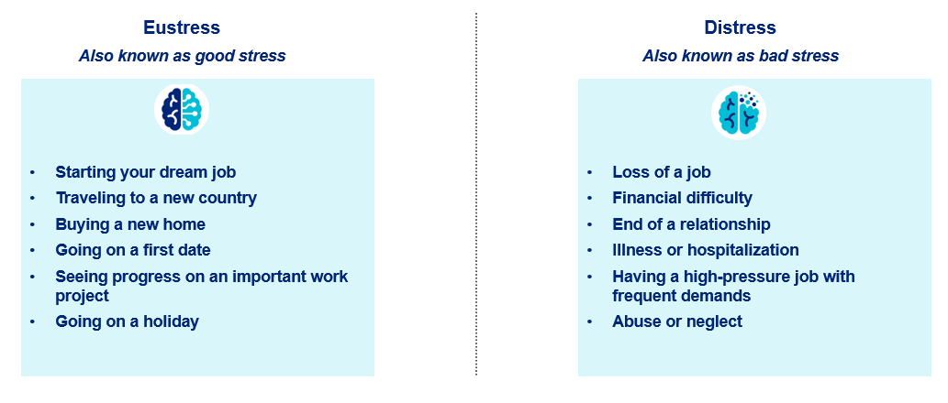
Whether positive or negative, if your stress has become a way of life, you're not managing it well. But you can learn how to cope better.
Click here to enter notes about good stress vs. bad stress.

Demands that lead to stress
The causes of stress can take many forms and are different for everyone. Stress is caused by external and internal factors.⁴
External Factors | Internal Factors
Major life changes | Negative self-talk
Work or school challenges | Unrealistic expectations/perfectionism
Relationship difficulties | Difficulty accepting uncertainty
Financial troubles | Ineffective time management

What demands are most stressful for you currently?
Click here to enter notes about the demands that can lead to stress.

Common stress responses
Life is full of changes, conflicts and demands. Many people are unaware of how much stress they’re under or the sources of that stress. Additionally, people are unaware of how they respond to stressful situations. Stress can show itself in cognitive, physical, emotional or behavioral ways.
The responses on the image below are some of the most widely reported responses to stress. However, everyone responds to stress and stressful situations differently. The fundamentals of successful stress management include knowing how you respond and how to take steps to address your response or responses in a constructive manner.
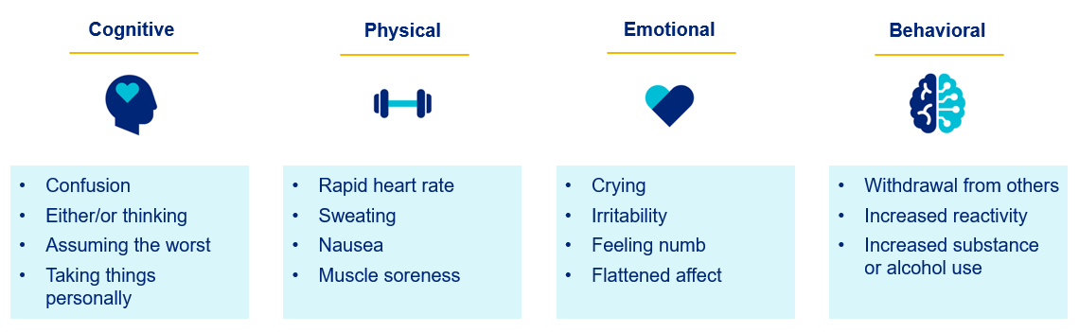
Which category do your responses typically fall into?
Click here to enter notes about the common responses to stress.

Stress or anxiety?
Stress and anxiety are frequently spoken about together because they share many similar symptoms and responses. It is important to keep in mind, however, that they are different.⁴
- Stress is the body’s response to a recognized threat or trigger and tends to last for a short period of time. Once the situation is resolved, so is the stress.
- Anxiety tends to last for a longer period of time than stress and may not have a trigger that can be identified.
Sometimes, stress can develop into anxiety. Stress is the body’s reaction to a threat, and anxiety is the body’s reaction to stress. If you can tie your feelings back to a specific trigger, they’re likely the result of stress. But if the exact cause isn’t clear, or your symptoms stick around after the initial trigger goes away, it may be anxiety.

Stress Management Strategies

Identify the causes of stress in your life
Stress management is more than reducing tension; it’s about building resilience and improving how you respond to life’s challenges. While stress can feel unavoidable, you have more control than you may think.
Effective stress management means taking charge of your thoughts, emotions, and environment. It’s about developing strategies that help you handle problems proactively. The ultimate goal? A balanced life that includes work, relationships, relaxation, and fun - plus the strength to stay steady under pressure and face challenges with confidence.
One of the first steps of stress management is to identify what is causing the stress. We can find it easy to identify major stressors such as changing jobs, moving, or going through a life event. However, determining the specific sources of chronic stress can be more difficult.
To identify what’s really causing you stress, look closely at your habits, attitude, and excuses.⁵ Ask yourself:
- Do you explain away stress as temporary even though you can’t remember the last time you took a breather?
  - “I just have too many competing things going on right now.”
- Do you define stress as an integral part of your work or home life or as a part of your personality?
  - “Things are always busy and disorganized around here.” or “I have a lot of nervous energy, that’s all.”
- Do you blame your stress on other people or outside events, or view it as entirely normal and unexceptional?
  - “I wouldn’t be so stressed if other people did what they were supposed to.”
Until you accept responsibility for the role you play in creating or maintaining it, your stress level will remain outside your control.
Click here to enter notes about identifying the causes of stress.

Replace unhealthy coping strategies with healthy ones
To cope with stress, we may sometimes use unhealthy coping mechanisms such as drinking or using substances, including over-the-counter medications, isolation, gambling, etc. These may work for a brief period of time by helping us feel better, providing a distraction, or covering up distressing symptoms, but in the long run, they can become problematic.
A healthy coping resource is one in which we are taking care of ourselves physically, mentally and emotionally. The healthier the coping skills are, the more resilient we are to the effects of stress. We minimize our chances of developing a stress-related illness or injury. When we use healthy coping mechanisms, it is possible to turn negative events into positive outcomes.
Healthy coping strategies include: ⁶


Eating a healthy diet - there is evidence showing how food affects our mood. Feelings of wellbeing can be protected by ensuring that our diet provides adequate amounts of brain nutrients.

Physical exercise – working out can be very effective. Even light exercise such as a brief walk can help. Consult a healthcare professional before beginning an exercise routine.

Practicing mindfulness – this can help reduce the effects of stress and be practiced at any time and in any location.

Getting enough sleep/rest - if we compromise our sleep, we compromise our performance, our mood, and our interpersonal relationships.

Being aware of drinking and/or smoking – despite feeling like tension is reduced, they actually add to stress and your body’s response.

Being kind to yourself – everyone has bad days from time to time. It is important to keep things in perspective and give yourself some grace in difficult situations.

Seeking professional help - asking for professional help if you feel that you are struggling to manage on your own is a good thing. It’s also important to get help as soon as possible so you can begin to get better.
Click here to enter notes about health coping strategies for stress.

Practice change techniques
There are many effective ways to manage stress such as making changes. You can choose to change the situation or adjust how you respond to it. The key is to select strategies that fit your needs and feel sustainable for you.
Four relatively simple change strategies to utilize are:⁵
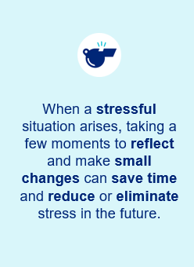
- Avoid unnecessary stress: Not all stress can be avoided, but there are several small stressors you can eliminate.
        - Learn to say “no” – Know your limits and stick to them.
  - Take control of your environment - For example, if watching the news makes you anxious, skip the broadcast. If heavy traffic makes you nervous, choose a different route.
  - Shorten your “to-do” list - When your to-do list feels overwhelming, separate the “must-dos” from the “nice-to-dos” and prioritize essential tasks.

- Alter the situation: If you can’t avoid stress, look for ways to change the situation. Consider speaking up and sharing concerns openly and respectfully instead of bottling them up.
  - Be proactive - Address issues early and assertively to prevent bigger problems.
  - Find balance - Mix work with rest and enjoyable activities to avoid burnout.
- Adapt to the stressor: When you can’t change the stressor, change your perspective.
  - Reframe challenges and keep perspective.
  - Lower perfectionism - Aim for “good enough” instead of flawless.
  - Practice gratitude - Focus on what you appreciate to restore balance.
- Accept the things you cannot change: When stressors can’t be avoided, practice acceptance.
  - Let go of control - Focus on what you can influence such as your reactions.
  - Look for positive aspects - See challenges as opportunities to learn and grow.
  - Forgive and release - Free yourself from anger and resentment by forgiving.
Click here to enter notes about change techniques.

Reframe your thoughts
On a day-to-day basis, how do you talk to yourself?
- Are you self-critical? Are you a perfectionist?
- Are you constantly thinking of the next task to do, what happened yesterday, what you need to do tomorrow, or next week?
Another way to manage stress is to reframe negative thoughts and self-talk in a positive light:⁷
Rewrite negative self-talk
“It’s overwhelming” |  | “I’ll take it piece by piece”
“Here we go again” |  | “This time things can be different”
“This won’t work” |  | “I’ll give it another try”
“I should help my friends and family out more” |  | “It’s okay to say ‘no’”


Click here to enter some examples of negative self-talk you may have engaged in recently.

By being more conscious of the present moment and in the present moment through mindfulness, you may become more aware of your negative self-talk and be able to “rewrite” negative self-talk while it’s happening, so you can focus on positive self-talk and thoughts.

Slow-down strategies
Sometimes, one of the best things we can do for ourselves to manage stress is simply to slow down or pause and walk away momentarily. When things start to get out of control, don’t be afraid to pause, calm down, gain composure and think more clearly.
Most of us do the reverse. We speed up and race around trying to get more done, often getting distracted and getting less done.
Think of the following suggestions as a toolbox of different methods that can be used to slow down, keep a productive pace, and feel centered:⁸
- Stretch - Stop and do a few stretches, it may help you feel more comfortable and energized.
- Listen to your body - Stop to check in with your body. Are your teeth clenched, your shoulders tight, your breathing shallow? Are you hungry or thirsty? Don’t override the call for help from your body with caffeine or alcohol. Find time to stretch, breathe and meditate.

- Meditate - This involves a conscious clearing of the mind, silencing all the thoughts and conversations that we carry on with ourselves.
- Exercise - Find an activity that you enjoy: walking, running, dancing, swimming, anything that gets you moving. *Consult a healthcare professional before beginning an exercise routine.
- Take care of yourself - Eat right. Get enough sleep. Take care of yourself by taking care of your health so you have the energy you need to enjoy life.
- Breathe deeply - Under times of stress we tend to take quick, shallow breaths, increasing the feeling of stress. Slow down and remember to breathe deeply, from your abdomen. Inhale, expand your stomach and fill your lungs completely. Exhale slowly through your mouth, trying to empty your lungs.
- Set aside time to relax every day - If your meeting ended early, treat yourself to something at a local café, or do nothing.
- Connect with a friend or loved one - Spending time with those who emotionally support you makes a difference. Make time to talk to people you care about.

Click here to enter additional ways you can slow down.


Let’s reflect
Think about how you have managed stressful situations in the past.
- What other skills do you think are helpful to manage stress?
- What are the benefits of having the skills to manage stress effectively?
Click here to reflect on past stressful situations.

Putting Strategy Into Practice

4-7-8 breathing exercise

When you feel stressed, your body’s sympathetic nervous system takes over. That can lead to your “fight or flight” response engaging. This response helps you when you’re in danger or in a situation that requires acting quickly.
A simple and helpful way to relieve stress is to try the 4-7-8 breathing exercise. Integrative medicine specialist Dr. Andrew Weil is the Clinical Professor of Medicine and Professor of Public Health at the University of Arizona. He developed 4-7-8 breathing as a simple and useful way to help manage mild-to-moderate stress and anxiety. ⁹
When done properly, 4-7-8 breathing activates your parasympathetic nervous system. That decreases your heart rate and blood pressure. It can help you build resilience and overall wellbeing over the long term.
To practice 4-7-8 breathing:
- Get into a comfortable position, such as sitting up straight or lying down (when doing this on your own).
- Place the tip of your tongue against the tissue behind your upper front teeth.
4
Slowly inhale through your nose to a mental count of 4
7
Hold your breath for a mental count of 7
8
Exhale – making a “whoosh” sound – through your mouth to the mental count of 8

It is recommended to repeat the exercise for 4 breath cycles, twice a day. As you learn to relax and control your breath with 4-7-8 breathing, your body will be learning, too. After a while, your body will get used to triggering the exercise when your stress level rises — to help you find calm.

“5-4-3-2-1” grounding
When feeling stressful or panicked, our mind races and thoughts can immediately go to worst case scenario thinking. In the midst of these feelings, it can be difficult to see that there can be a way out. Simple exercises such as grounding techniques can help. They are mental and emotional exercises that help to reconnect with the present moment and reduce feelings of stress and anxiety.
One simple grounding technique that can easily be remembered when our minds are busy is the 5-4-3-2-1 grounding technique. It involves using our senses to “pull” ourselves back to the present moment and re-establish a sense of calm.
The technique steps are:¹⁰
5
Identify five things that you can see and describe them in detail
4
Identify four things you can feel
3
Identify three things you can hear
2
Identify two things you can smell
1
Identify one thing you can taste

This exercise makes us more aware of our sensory experience and interrupts the anxiety loop that we may find ourselves in. It’s an immediate distraction to divert intrusive thoughts and help to refocus on the present in a healthy way.

Progressive Muscle Relaxation (PMR)

PMR is an anxiety-reduction technique first introduced in the 1930s.¹¹ The technique involves alternating tension and relaxation in the body's major muscle groups.
To practice this technique, follow these steps:
Getting ready
- Find a quiet place, free from distractions
- Lie on the floor or recline in a chair
- Rest your hands in your lap or on the arms of a chair
- Take a few slow, even breaths

Practice, beginning with your forehead
- Squeeze the muscles, holding for 15 seconds
- Feel the muscles becoming tighter and tenser
- Slowly release the tension while counting to 30. Notice how the muscles feel as you relax
- Continue to release the tension until your forehead (or other part of the body) feels completely relaxed. Breathe slowly and evenly
Continue these steps, moving down the body focusing on your jaw, neck and shoulders, arms and hands, buttocks, legs, and feet.
This simple exercise can be done anytime and anywhere to help relieve stress quickly.

Other actions to consider
When addressing and managing stress, it is important to begin by recognizing stressful situations and making the choice to do something about it. Ignoring your response to stress and stressful situations can make problems worse and possibly add new ones.
The key to success is doing what is best for you. Some additional techniques could be:¹

Connect with others - Having a strong support system—whether it’s colleagues, friends, or family—can lighten your stress and offer fresh perspectives on challenges. Spending time with friends through shared activities can be a great way to unwind and recharge.
Practice self-care - Making space for relaxation or movement isn’t just a luxury - it’s essential for our wellbeing. Consider carving out time just for yourself—whether it’s to unwind, catch up with friends, or simply enjoy a quiet moment away from work or life’s challenges.
Start a gratitude journal - Write about three things you are grateful for each day to increase positive emotions. Jot down some positive affirmations or statements about yourself. This can help combat negative self-talk and increase self-esteem.
Challenge yourself - Taking on new goals, like picking up a language or trying a new sport, can boost your confidence and give you a sense of progress, which can be a powerful way to manage stress. These kinds of challenges can also spark motivation and encourage you to stay active and engaged in life.
Click here to enter your notes about ways to manage stress.

Employee Assistance Program (EAP)
- Short term counselling and support for all employees and immediate family members (if eligible).

- Provided at no cost to you by your employer.

- Easily accessible, voluntary, and confidential in accordance with the law – a service that can provide support for personal or work-related issues.

- Staffed by experienced professionals.

“This program should not be used for emergency or urgent care, call the local emergency services phone number, or go to the nearest emergency room. This program is not a substitute for doctor’s or professional’s care. Due to the potential for a conflict of interest, legal consultation will not be provided on issues that may involve legal action against United Healthcare or its affiliates, or any entity through which the caller is receiving these services directly (e.g., employer). This program and its components may not be available in all locations or for all group sizes and is subject to change. Coverage exclusions and limitations may apply. The United Healthcare EAP information in this training is only applicable to the eligible members in attendance.”

About professional support
You may consider seeking professional support if you experience any of the following:
- Sleep problems.
- Performance issues at work.
- Relationship difficulties with family or friends.
- Loss of interest in hobbies you normally enjoy.
- Lack of care about normal everyday work tasks.
- Excessive anxiety or worrying more than normal.
- Feeling overwhelmed or sad for more than two weeks.
- A noticeable change in appetite, eating too little or too much.
- Behavior and coping methods have become harmful to yourself
or others, whether that is through aggressive behavior or unhealthy habits, such as drinking too much alcohol or taking drugs.
- Thoughts of harm to self and/or others. *

Keep in mind some of these conditions may warrant more urgent professional help.

Your employee assistance program (EAP) is available to all employees and their covered dependents and may include some free counseling sessions per issue, per year. Please check with your employer or your health plan for details.

*If you or someone you know have thoughts about suicide or are in crisis, seek help right away. If you or someone you know is in immediate danger, call 911 — or go to the closest emergency room.

Let’s reflect
Take some time to answer the questions below using the “Enter text here” boxes provided to record your answers.

- What is one thing that you have learned from this program?
Enter text here

- What is one thing that you would like to research more?
Enter text here

References
¹NHS. (n.d.). Dealing with stress. NHS Better Health. https://www.nhs.uk/every-mind-matters/mental-health-issues/stress/. Accessed 28 Oct. 2025.
²World Health Organization. (21 Feb. 2023). Stress. World Health Organization. https://www.who.int/news-room/questions-and-answers/item/stress#:~:text=Stress%20can%20be%20defined%20as,experiences%20stress%20to%20some%20degree. Accessed 28 Oct. 2025.
³Perry, E. (16 Aug. 2022). Rethink Your Relationship with Stress. It turns out, it’s not all bad. BetterUp. https://www.betterup.com/blog/what-is-eustress. Accessed 28 Oct. 2025.
⁴Segal, J. Ph.D., Smith, M. and Robinson, L. (14 April 2025). Stress symptoms, signs, and causes. HelpGuide.org. https://www.helpguide.org/articles/stress/stress-symptoms-signs-and-causes.htm. Accessed 28 Oct. 2025.
⁵Robinson, L. and Smith, M., M.A. (02 Sept. 2025). Stress Management: Techniques and Strategies to Deal with Stress. HelpGuide. https://www.helpguide.org/mental-health/stress/stress-management. Accessed 29 Oct. 2025.
⁶Mental Health Foundation. (n.d.). How to manage and reduce stress. Mental Health Foundation. https://www.mentalhealth.org.uk/explore-mental-health/publications/how-manage-and-reduce-stress. Accessed 29 Oct. 2025.
⁷Thorn, B. Ph.D. (22 Oct. 2024). 11 Healthy ways to handle life’s stressors. American Psychological Association. https://www.apa.org/topics/stress/tips. Accessed 29 Oct. 2025.
⁸National Institute of Mental Health. (n.d.). I’m so Stressed Out Fact Sheet. https://www.nimh.nih.gov/health/publications/stress/index.shtml. Accessed 29 Oct. 2025.
⁹Cleveland Clinic. (06 Sept. 2022). How to do the 4-7-8 Breathing Exercise. The Cleveland Clinic. https://health.clevelandclinic.org/4-7-8-breathing. Accessed 30 Oct. 2025.
¹⁰Gupta, S. (29 April 2024). Feeling Anxious? Try the 5-4-3-2-1 Grounding Technique. VeryWell Mind. https://www.verywellmind.com/5-4-3-2-1-grounding-technique-8639390#:~:text=Then%2C%20pay%20attention%20to%20the,of%20sounds%20and%20their%20qualities. Accessed 30 Oct. 2025.
¹¹Cuncic, A. (22 May 2025). How to Practice Progressive Muscle Relaxation. Verywell Mind. https://www.verywellmind.com/how-do-i-practice-progressive-muscle-relaxation-3024400. Accessed 30 Oct. 2025.

