
Maintaining Balance in Life

Contents
The session 2
Understanding life balance 3
What is life balance?.................................................................................................................................3
Why does life balance matter?..................................................................................................................3
Dimensions of a balanced life……………………...…………………………………………………………….3
Reflection - dimensions of life balance………………………………………..………………………………...5
Common challenges to life balance 6
Strategies for maintaining life balance 8
Reflection - strategies for maintaining life balance………………………..………………………………….10
Emotional Wellbeing Solutions (EWS) 11
About professional support 11
Let’s reflect 12
References 13

The session
In today’s fast-paced world, competing demands from work, family, health, and personal growth can easily lead to stress and burnout. Balance isn’t just about managing time; it’s about sustaining mental, emotional, and physical health while meeting life’s demands. When balance is neglected, productivity and creativity decline, stress and health issues increase, and relationships suffer. By learning to prioritize effectively, manage stress, and set boundaries, you can strengthen resilience, improve focus, and foster healthier relationships and personal growth.
The following key topics will be covered:

Define true balance in life and why it matters for overall wellbeing.

Recognize the key dimensions that require attention to maintain life balance.

Identify the hidden challenges that disrupt life balance.

Learn practical strategies to create and maintain balance in life.

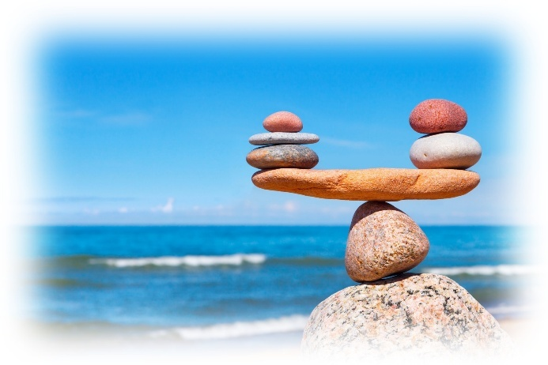
What does balance in life mean to you?
Click here to enter your answer.

Understanding life balance
What is life balance?


In the context of maintaining a balanced life, balance refers to the harmonious alignment of different aspects of life, such as physical, mental, emotional, and social wellbeing. It involves prioritizing and nurturing these elements to foster a sense of fulfillment and wellbeing. Balance is not about doing everything equally; rather, it is about finding the right proportion for your life, ensuring that no single area dominates and depletes the others. It is about consciously nurturing all facets of your being, ensuring they receive the attention and care they deserve.¹

Why does life balance matter?
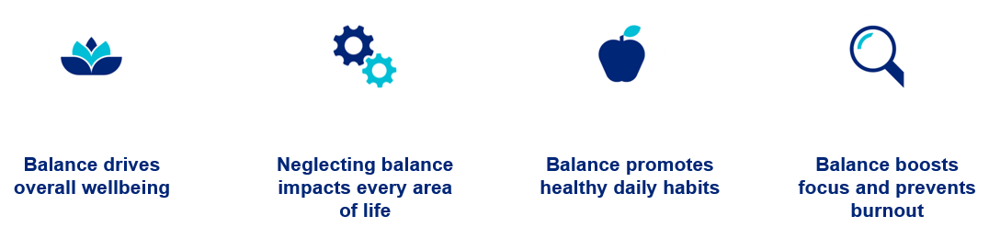

A balanced lifestyle is essential for overall wellbeing. When any aspect of life is neglected, it affects everything else. Living in balance promotes healthy habits like proper nutrition, exercise, and sleep, which strengthen the body and boost energy. It also reduces stress, enhances emotional stability, and supports positive thinking. Balance allows time for meaningful relationships, improving connection and support. It increases productivity by sharpening focus and preventing burnout, and it fosters fulfillment by enabling people to pursue passions and live with purpose. In short, balance keeps life running smoothly—physically, mentally, and emotionally.¹

Dimensions of a balanced life

Achieving balance in life is essential for overall wellbeing and success. Let’s explore the key dimensions that contribute to a balanced, healthy, fulfilling lifestyle. Each dimension plays a unique role in shaping how you think, feel, and interact with the world. By understanding and nurturing these areas, you can create harmony between personal and professional life, build resilience, and experience greater satisfaction and purpose.
 | Mental health² | Mental health is about cultivating a strong and positive mindset that supports overall wellbeing. Developing this mindset is essential for achieving clarity, building confidence, and fostering the ability to learn and grow. It also encourages creativity and independent thinking, enabling individuals to adapt and thrive in both personal and professional settings.
 | Physical health² | Physical health involves caring for our bodies through balanced nutrition, regular exercise, and adequate sleep. When we prioritize these habits, we support the body’s ability to function optimally, boost energy levels, and enhance overall wellbeing.
 | Emotional wellness² | Emotional wellness is about recognizing how our thoughts and feelings influence our actions, behaviors, and outcomes. Our emotions play a powerful role in shaping motivation and decision-making. When we acknowledge and embrace what we feel, we gain deeper self-understanding and develop the resilience needed to cope with life’s challenges effectively.
 | Spiritual² | Spiritual focuses on personal growth and the pursuit of meaning, purpose, and values in life. It involves living in alignment with your own principles, cultivating inner peace, and approaching each day with mindfulness and gratitude. By nurturing this aspect, individuals can experience a deeper sense of fulfillment and happiness.
 | Social² | Social focuses on building and maintaining healthy, meaningful connections with others. Surrounding yourself with supportive and positive relationships is essential because it fosters a sense of safety, respect, and belonging. Strong social ties not only enhance emotional wellbeing but also contribute to resilience and overall life satisfaction.
 | Environmental² | Environmental wellness focuses on creating and maintaining surroundings that support your wellbeing while respecting the natural world. Your environment, both personal spaces and the broader ecosystem, directly influences your mindset, creativity, and productivity. This includes organizing and caring for your immediate environment as well as practicing habits that protect resources like air, water, and earth.
 | Financial² | Financial focuses on an individual’s relationship with money and the ability to manage it effectively. It involves developing skills to handle expenses, plan for the future, and reduce financial stress. Since financial concerns are one of the leading sources of stress for many people, maintaining stability in this area is essential for mental wellbeing and overall quality of life.
 | Occupational² | Occupational centers on your work life, whether you own a business or have a job or career. It’s about creating a healthy balance between professional responsibilities and personal life while pursuing growth in a sustainable way. There is an emphasis on advancing your career or building your business without sacrificing wellbeing and finding satisfaction and purpose in the work you do.

Reflection – dimensions of life balance

Dimension of life balance | Rating | Check box
Mental health | Click here to enter your rating. | ☐
Physical health | Click here to enter your rating. | ☐
Emotional wellness | Click here to enter your rating. | ☐
Spiritual | Click here to enter your rating. | ☐
Social | Click here to enter your rating. | ☐
Environmental | Click here to enter your rating. | ☐
Financial | Click here to enter your rating. | ☐
Occupational | Click here to enter your rating. | ☐


Which area needs more attention?
Click here to enter your answer.

Which area feels the strongest?
Click here to enter your answer.

Think about why those areas scored the way they did – what’s contributing to your satisfaction or dissatisfaction?
Click here to enter your answer.

Common challenges to life balance
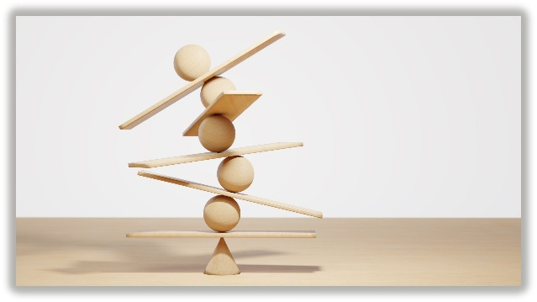
Maintaining balance in life isn’t just a nice-to-have, it’s essential for overall wellbeing and success. When balance slips, common challenges like chronic stress, burnout, and strained relationships can quickly take hold, impacting both personal and professional life. Physical health may suffer, emotions can feel unpredictable, and productivity often declines despite working harder.

Let’s explore these challenges, helping you recognize the warning signs and understand why creating balance is key to thriving.
When balance is missing, stress becomes a constant presence. The endless chase for deadlines and neglect of personal time can leave you feeling overwhelmed. Chronic stress impacts not only mental wellbeing but also physical health, contributing to issues like high blood pressure and a weakened immune system.
Chronic stress³

Burnout happens when life’s demands outpace your ability to cope. Overworking while skimping on rest creates a cycle of exhaustion that drains productivity and robs life of enjoyment.
Burnout³

An unbalanced life often takes a toll on relationships. Skipping time with loved ones can lead to isolation and disconnection, straining even the strongest bonds.
Strained relationships³

Ignoring essential self-care, such as exercise, proper nutrition, and sleep, can gradually harm your physical health. From weight gain to chronic conditions, the consequences of imbalance are serious.
Poor health³

Emotional instability³
Living without balance can heighten anxiety, trigger mood swings, and lead to feelings of despair. Without time to process emotions, life can feel like an endless emotional rollercoaster.

When obligations overshadow passions, life can feel monotonous. This imbalance limits opportunities for growth and joy, leaving you stuck in routine.
Lack of fulfillment³

Ironically, trying to juggle too much often results in achieving less. Overcommitting and multitasking increase mistakes and lower efficiency, adding more stress over time.
Reduced productivity³

Poor financial balance—whether through overspending or neglecting planning—can create long-term instability and fuel anxiety about the future.
Financial stress³

Consistently ignoring personal needs can erode confidence and foster feelings of inadequacy. Over time, this imbalance damages self-esteem and self-image.
Low self-worth³

Without clear priorities, life can feel disorganized and overwhelming. Managing multiple roles without structure often leads to chaos and a lack of direction.
Sense of chaos³




What challenge most resonates with you and why?
Click here to enter your answer.

Strategies for maintaining life balance

Now that you’ve explored what balance means and the challenges that make it difficult, let’s focus on practical strategies you can start using today. These strategies are simple but powerful when applied consistently.

Clarify priorities and set goals^{4 and 5} - Balance begins with knowing what matters most. Identify your core priorities and distinguish importance from urgency, scheduling around what truly brings fulfillment. Once priorities are clear, set realistic, meaningful goals that provide direction and motivation without being overwhelming. Adjust as needed to stay sustainable. This approach promotes progress, control, and wellbeing in both your work and personal lives.


Click here to enter your notes.



Prioritize self-care and connection^{4 and 5} - Self-care is essential, not optional. Activities like exercise, rest, healthy eating, and mindfulness help you recharge physically and mentally. Equally important is spending regular, quality time with loved ones—simple, consistent moments of connection strengthen relationships and provide emotional balance. Together, these practices create the foundation for wellbeing and fulfillment.


Click here to enter your notes.

Effective time management^{4 and 5} - Balancing work, family, and personal wellbeing starts with managing time wisely. A well-planned schedule helps prevent overwhelm by allocating time for key priorities like work tasks, relationships, and self-care. This approach ensures attention to what matters most and creates harmony among competing demands.


Click here to enter your notes.

Cultivate work-life balance^{4 and 5} - Set boundaries so work doesn’t overshadow personal life. Quality time with loved ones is vital for happiness and strong relationships. Balancing career and personal time supports wellbeing and creates a reliable support system.¹⁵

Click here to enter your notes.

Foster positive relationships^{4 and 5} - Strong connections with family and friends provide emotional support, belonging, and stability. Nurturing these relationships through communication, empathy, and shared experiences creates harmony and enriches life. Positive relationships are a two-way street—giving and receiving care builds trust and fulfillment.


Click here to enter your notes.

Healthy lifestyle essentials^{4 and 5} - A balanced life thrives on two pillars: regular exercise and proper nutrition. Physical activity boosts energy, strengthens the body, and releases endorphins that improve mood, reduce stress, and enhance mental clarity. It also supports cognitive function and productivity. Likewise, a balanced diet fuels consistent energy, stabilizes mood, and promotes overall health. The key is integration—making movement and healthy eating part of your daily routine for sustained wellbeing.¹⁵


Click here to enter your notes.

Embrace flexibility^{4 and 5} - Life is unpredictable, and flexibility is key to maintaining balance. Being adaptable means letting go of rigid expectations, embracing change, and viewing challenges as opportunities for growth. A flexible mindset fosters resilience, reduces stress, and helps you navigate life’s detours with grace.


Click here to enter your notes.

Set boundaries and learn to say no^{4 and 5} - Maintaining balance requires protecting your time and energy. Clear boundaries prevent others’ priorities from overshadowing your own, while saying “no” helps avoid overcommitment and burnout. Declining tasks isn’t selfish; it’s a way to honor your wellbeing and focus on what truly matters. Evaluate new commitments carefully and choose those that align with your priorities for a healthier, more balanced life.


Click here to enter your notes.

Mindfulness, gratitude, and personal passions^{4 and 5} - Cultivating inner balance starts with mindfulness and meditation, which reduces stress, improves focus, and promotes emotional wellbeing. Pair this with gratitude, a practice that shifts perspective, boosts happiness, and strengthens mental health. Finally, make time for passions and hobbies—creative outlets that bring joy, relaxation, and a sense of accomplishment. Together, these habits foster clarity, resilience, and fulfillment in a busy world.¹⁵


Click here to enter your notes.

Reflection – strategies for maintaining life balance


What is one area of your life that needs improvement?
Click here to enter your answer.

What strategies for maintaining balance can you use to improve that area of your life?
Click here to enter your answer.

Emotional Wellbeing Solutions (EWS)
- Short term counselling and support for all employees and immediate family members (if eligible).

- Provided at no cost to you by your employer.

- Easily accessible, voluntary, and confidential in accordance with the law – a service that can provide support for personal or work-related issues.

- Staffed by experienced professionals.

“This program should not be used for emergency or urgent care, call the local emergency services phone number, or go to the nearest emergency room. This program is not a substitute for a doctor’s or professional’s care. Due to the potential for a conflict of interest, legal consultation will not be provided on issues that may involve legal action against Optum or its affiliates, or any entity through which the caller is receiving these services directly (e.g., employer). This program and its components may not be available in all locations or for all group sizes and is subject to change. Coverage exclusions and limitations may apply. The Optum EWS information in this training is only applicable to the eligible members in attendance.”

About professional support
You may consider seeking professional support if you experience any of the following:
- Sleep problems.
- Performance issues at work.
- Relationship difficulties with family or friends.
- Loss of interest in hobbies you normally enjoy.
- Lack of care about normal everyday work tasks.
- Excessive anxiety or worrying more than normal.
- Feeling overwhelmed or sad for more than two weeks.
- A noticeable change in appetite, eating too little or too much.
- Behavior and coping methods have become harmful to yourself
or others, whether that is through aggressive behavior or unhealthy habits, such as drinking too much alcohol or taking drugs.
- Thoughts of harm to self and/or others. *

Keep in mind some of these conditions may warrant more urgent professional help.

Your EWS employee assistance program (EAP) is available to all employees and their covered dependents and may include some free counseling sessions per issue, per year. Please check with your employer or your health plan for details.

*If you or someone you know have thoughts about suicide or are in crisis, seek help right away. If you or someone you know is in immediate danger, call 911 — or go to the closest emergency room.

Let’s reflect
Take some time to answer the questions below using the “Enter text here” boxes provided to record your answers.

- What is one thing that you have learned from this session?
Enter text here

- What is one thing that you would like to research more?
Enter text here

References
¹Sonam Tobgay. (13 January 2024). What is a Balanced Lifestyle and Why is it Important? Healthy Lifestyle. https://www.healthworldbt.com/what-is-a-balanced-lifestyle/. Accessed 11 November 2025.
²Michelle. (9 March 2021). The 8 elements of a balanced life (life balance wheel). The Balanced CEO. https://thebalancedceo.com/balanced-life/. Accessed 11 November 2025.
³Naledi, M. (29 January 2025). 10 Struggles of Living Without Balance—and How to Overcome Them - Naledi Mqhayi. Naledi Mqhayi - Clinical Psychologist & Executive Coach. https://naledimqhayi.com/struggles-of-living-without-balance/. Accessed 11 November 2025.
⁴WellnessSeeker. (28 October 2023). 12 Strategies for Achieving Balance in Your Life -. Vitalitywellnesspath.com. https://vitalitywellnesspath.com/12-strategies-for-achieving-balance-in-your-life. Accessed 11 November 2025.
⁵Mooremomentum. (6 July 2025). How to Find Balance in Life: 9 Game-Changing Strategies - Habits Coach. Habits Coach. https://habitscoach.ai/blog/how-to-find-balance-in-life/. Accessed 11 November 2025.

